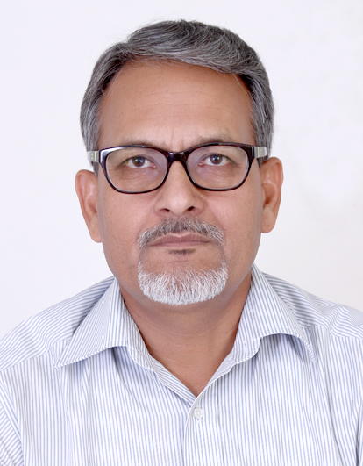

**Prof. R.S. Salaria**

Prof. R. S. Salaria

* President, Innovative Foundation for Holistic Education (IFHE).
* Alumnus of IIT, Delhi.
* Certified Software Quality Professional (CSQP) by Govt. of India.
* SUN Certified Programmer & Trainer by SUN Microsystems, USA.
* Certified Google Educator.
* Prominent Author of 26+ books of computer Science.